**PL/SQL Rest Services in R12.2.7**

AUTHOR: RAMYA

Table of Contents

|  |
| --- |
| 1. Overview………………………………………………………………………………………………………………………… 3 |
| 1. Integrated SOA Gateway…………………………………………………………………………………………………. 3 |
| 1. Exposing PL/SQL as REST Web Service in SOA gateway …………………………………………………… 3 |
| |  | | --- | | 3.1 Register Custom package as a API in SOA gateway…………………………………………………. 3 | | 3.2 Deploying a REST Service in SOA gateway ………………………………………………………………. 4 | | 3.3 Creating a Security Grants to REST service ……………………………………………………………… 7  3.4 Testing the Web services using WADL file ……………………………………………………………… 8 | |
| 1. Conclusion ……………………………………………………………………………………………………………………… 10 |

1. **Overview:**

This Document describes the process of exposing standard and custom API as REST Web Service using Integrated SOA Gateway.

1. **Integrated SOA Gateway:**

Oracle E-Business Suite Integrated SOA Gateway (ISG) is a complete set of service infrastructure to provide, consume, and administer Oracle E-Business Suite Web services. You can use this tool to easily discover and search on interfaces, regardless of custom or Oracle seeded ones.

1. **Exposing PL/SQL as REST Web Service in SOA gateway:**

**3.1 Register Custom package as a API in SOA gateway**

Steps to Create and Upload the PL/SQL Package as a API.

1. Create a custom Package.
2. Annotate the Package.
3. Upload package to oracle server.
4. Create ILDT file.
5. Upload the ILDT file to Integrated Repository.

Here we are creating REST Web services for **UTKARSH** Application to communicate mobile with

E-Business Suite. Following Steps will explain the process of Creating & uploading the Custom API (XXMOBL_API_PK).

1. Create a Custom package, for UTKARSH application we are creating the custom package **XXMOBL_API_PK**.
2. In order to register our custom Package in Integration Repository, we have to annotate our package Specification with Annotation standards.
3. Save the package in .pls (**xxmobl_api_pk.pls**) format. Upload the file into Oracle Server.
4. Create ILDT file by using Following command from putty.

|  |
| --- |
| perl $FND_TOP/bin/irep_parser.pl -g -v -username=sysadmin XXMOBL:patch/115/sql:xxmobl_api_pk.pls:12.0=xxmobl_api_pk.pls |

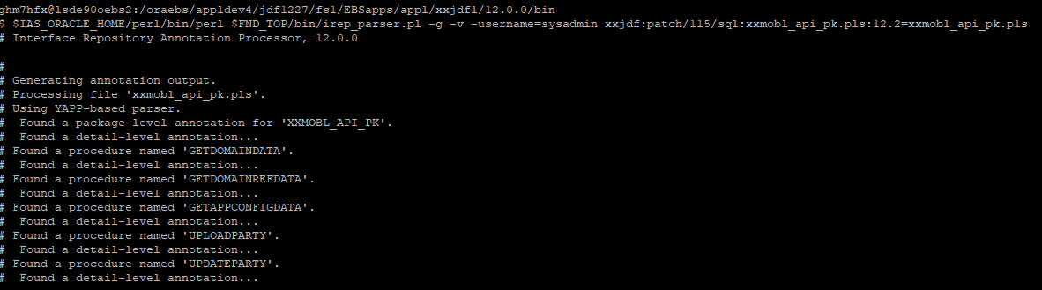

1. Upload the ILDT file to integration repository using below command.

|  |
| --- |
| FNDLOAD apps/apps_password 0 Y UPLOAD $FND_TOP/patch/115/import/wfirep.lct xxmobl_api_pk_pls.ildt |

**3.2 Deploying a REST Service in SOA gateway**

Use the following steps to deploy the rest service in SOA gateway.

1. Log in to Oracle E-Business Suite as a user who has the Integration Repository Administrator role. (USER: SYSADMIN)
2. Select the Integrated SOA Gateway responsibility and the Integration Repository link from the navigation menu.

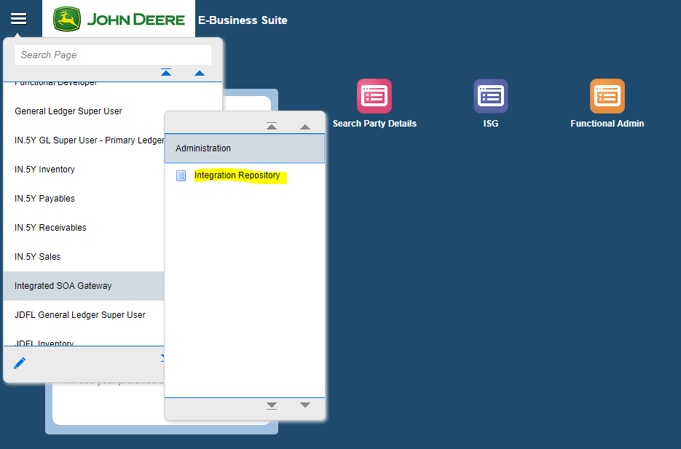

1. In the Integration Repository tab, click **Search** to access the main Search page.

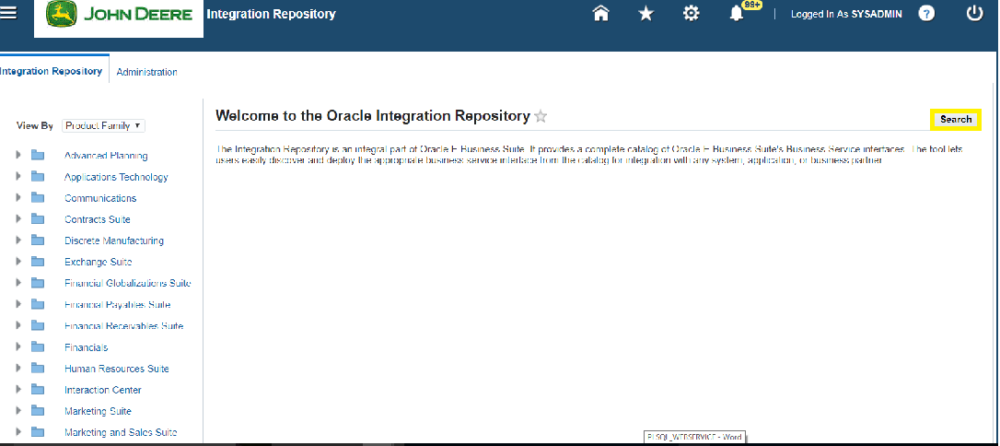

1. Enter the internal name (**XXMOBL%**) of the service to fetch the API from list, then click **Go** to execute the search.

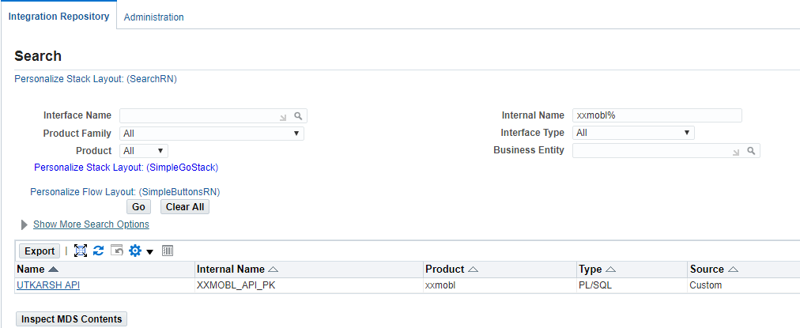

1. Click on **UTKARSH API** from search result list.
2. Go to REST web Service tab, you can see the list of methods available in the UTKARSH API.
3. Enter the **Service Alias** name and select the methods to deploy as a REST web service.

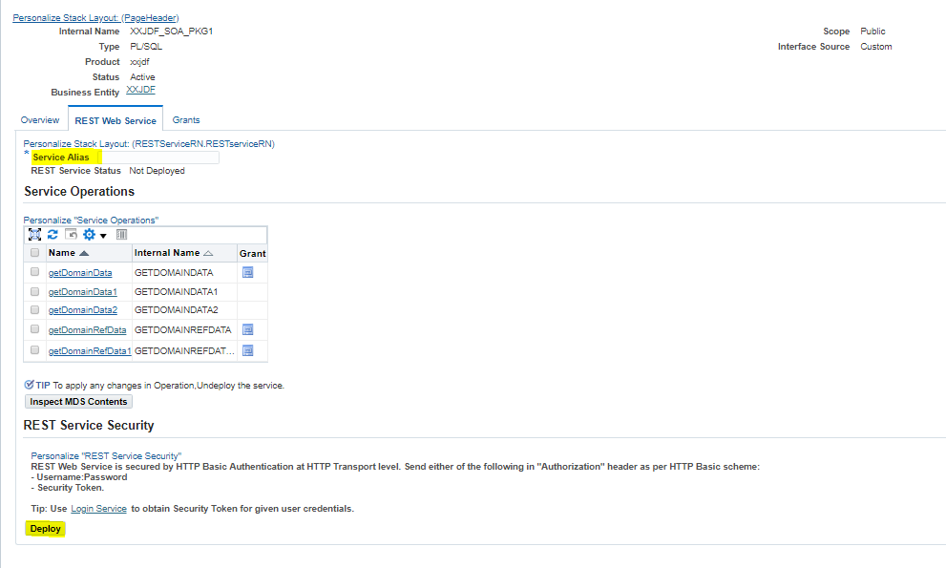

1. Click on **Deploy** to deploy the service to E-Business Suite Environment.
2. Now you will see the link to WADL file, Click on the link. It shows the physical location of the service endpoint where the service is hosted.

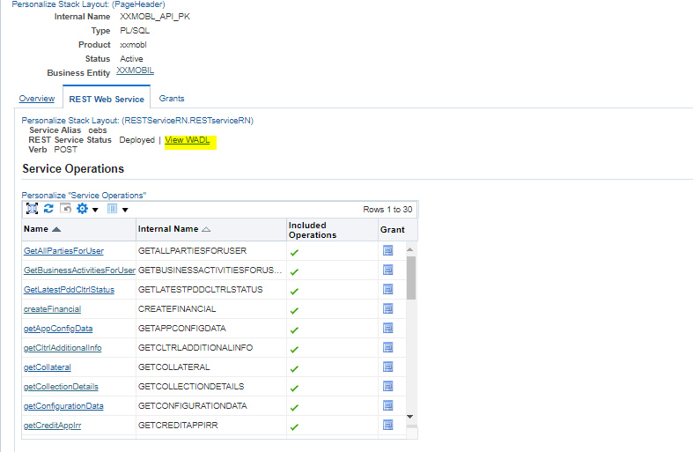

* 1. **Creating a Security Grants to REST service**

After deploying the REST Service Locator as a REST service, the integration administrator can create a security grant to authorize the service or method access privileges to a specific user, a user group, or all users.

use following steps to create a security grant.

1. Log in to Oracle E-Business Suite as a user who has the Integration Repository Administrator role. (USER: SYSADMIN)
2. Perform a search to locate the REST Service Locator service the administrator just deployed earlier.
3. In the interface details page of the selected custom PLSQL Services, click the Grants tab.
4. Select the method check box and click on Create Grant.

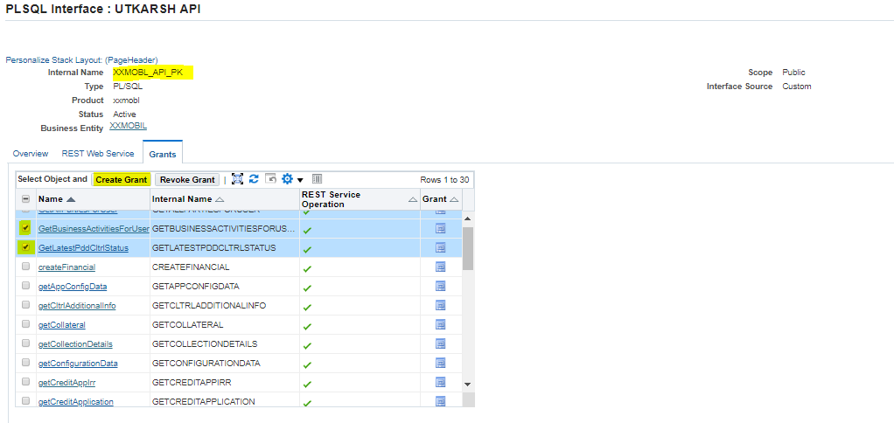

1. In the Create Grants page, select "**ASADMIN**" as the Grantee Type.

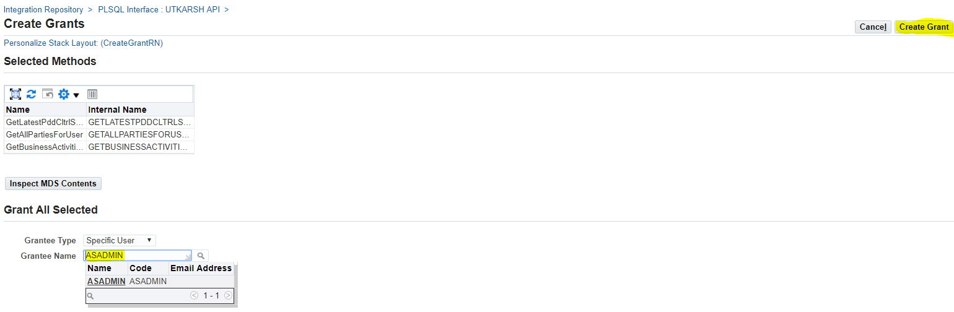

1. Click **Create Grant**. This grants the selected method access privilege to ASADMIN user.
2. Copy the WADL URL for further testing.
   1. **Testing the Web services using WADL file**

To Test the REST web service,

1. Create a REST project in SoapUI.

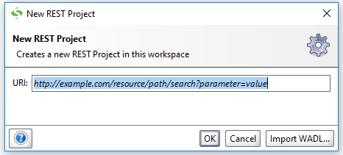

1. Import the WADL input url into the REST project.

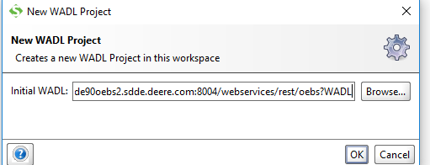

1. Open any of the method form the list of all web services.

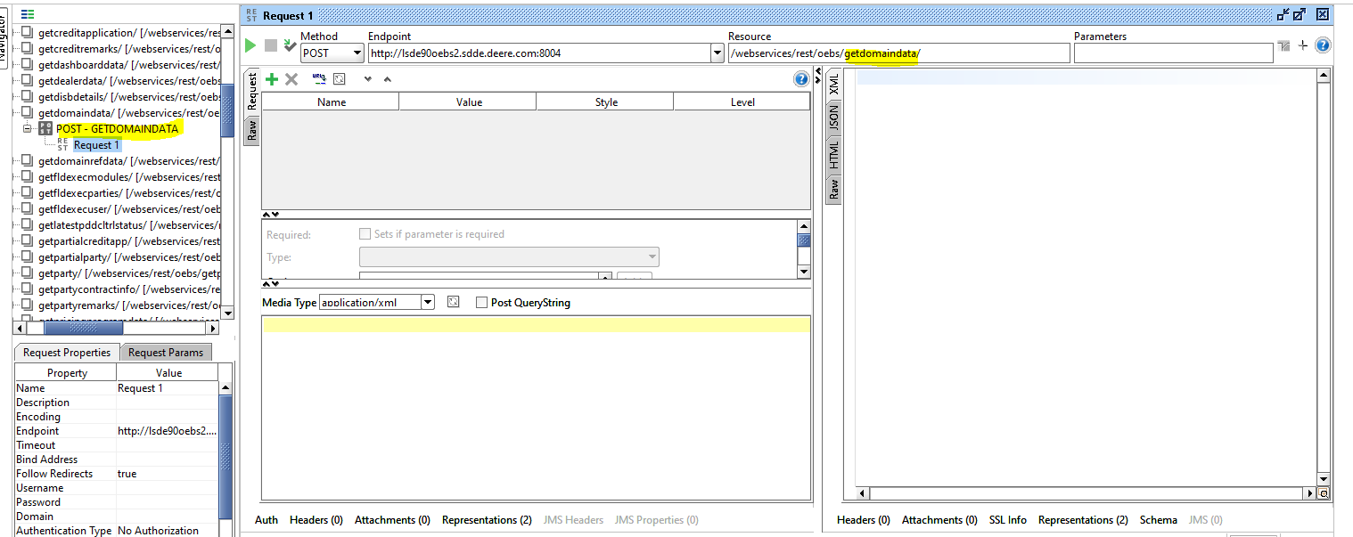

1. Enter the inputs in JSON format as UTKARSH team want in JSON.

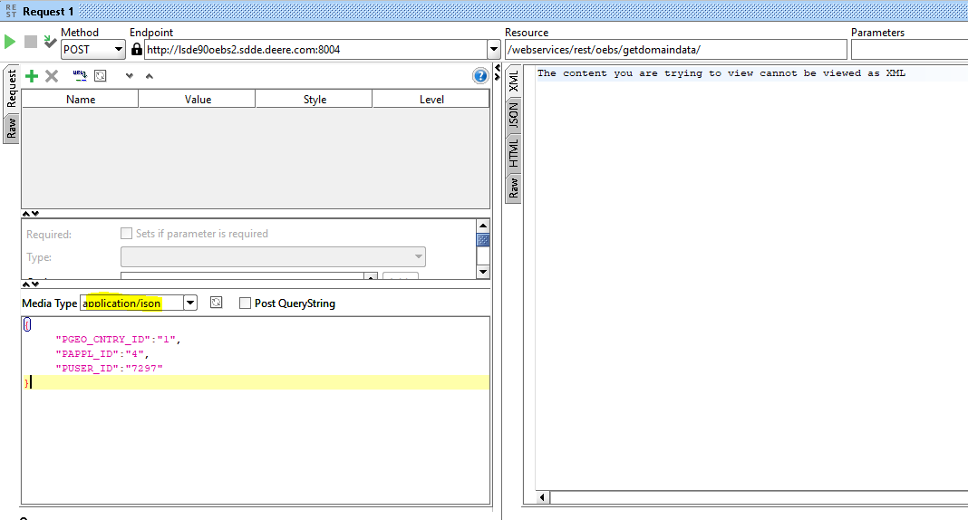

1. Provide the Basic Authentication(USER: ASADMIN) and RUN.

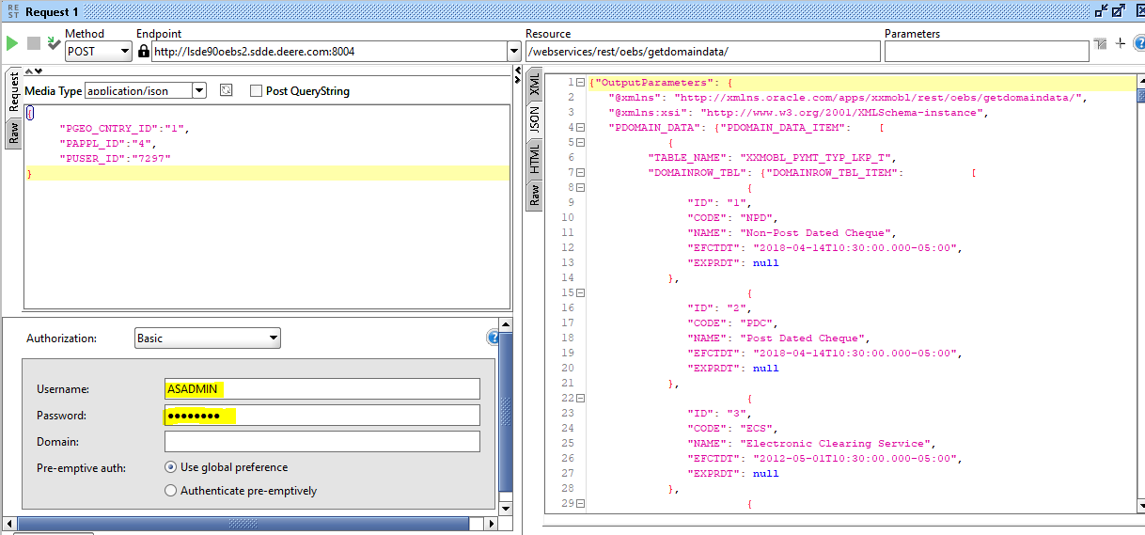

1. **Conclusion**

This document gives you an overview of the Integrated SOA Gateway and REST Web Services. It also gives you step by step instructions on exposing PL/SQL as REST Web from scratch. You should now be able to create REST Web Service either using Standard API or Custom API.